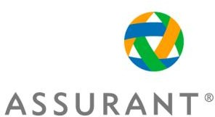

**Quality Management Document**

***Indian Automobile Solutions***

**Table of Contents**

Purpose: 2

Quality Control & Assurance Measurement Adopted 3

3

Quality Policy 4

4

4

Flow of Testing Process 5

**Quality Management Document** 

# Purpose:

The purpose of the Quality Management Document is to describe how quality will be managed throughout the lifecycle of the project. It also includes the processes and procedures for ensuring quality of the product being developed. All stakeholders should be familiar with how quality will be planned, assured, and controlled.

# Quality Control & Assurance Measurement Adopted

Our Quality Control Measurement involves step by step activities with a top-down approach. We

believe in identifying the root cause of the issues that we face while developing a product and fix

them as early as possible in order to produce the quality product within the stipulated time and

cost. We also involve Quality Assurance activities to ensure the

effectiveness of the development process that we are adopting to develop a software product.

We conduct process and

product reviews, and influence the resolution of corrective actions to ensure adherence to

documented processes. Our approach provides the best business alignment as well as the

framework to optimize the operations.

# 

# Quality Policy

## 

1. Implement well designed processes for ensuring the quality of all its products and services and improving them continuously.
2. Ensure that the products or services delivered meet customer requirements as well as statutory and regulatory requirements.
3. Integrate quality control and quality assurance activities into its software engineering processes.
4. Stress on building quality in its products and services by promoting error prevention through training, standards and checklists, tools, reuse and causal analysis.
5. Improve its processes, methodologies and techniques continuously by exploiting the evolving technologies to attain continuous improvements in its quality levels.
6. Implement workforce and solution delivery practices in line with the overall business framework to achieve strategic business objectives.



# 

# Flow of Testing Process

1. Requirement Analysis Phase: As soon as the new requirement is shared to testing team, We first understand and review the requirement in order to find any ambiguity in it and then discuss it with the project lead and BA.
2. Test Case Design Phase: In this phase we prepare test cases based on the requirement shared to testing team, and reviews designed test cases that satisfies the requirements previously documented.
3. Testing Execution Phase: In this phase we execute the test cases and check its actual behaviour and compare it with the expected behaviour. The purpose of executing test cases is to ensure that the new functionality (Integration Testing) or complete system (System Testing) functions as intended.  
     
    Sample Test Case

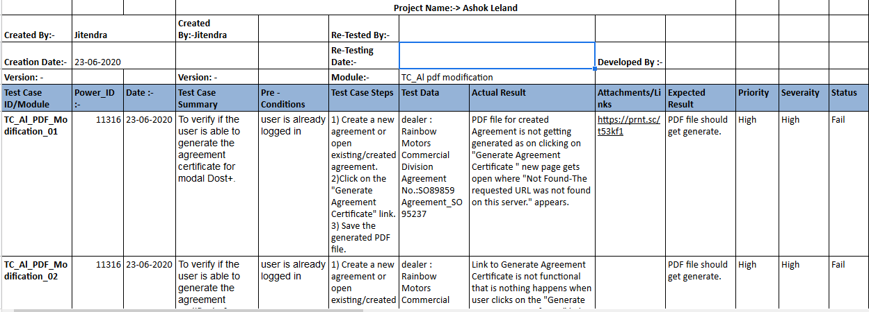

1. Bug Reporting: In this phase we prepare bug report of the failed test cases. And report it to the concerned developer.  
     
    Sample Bug Report  
   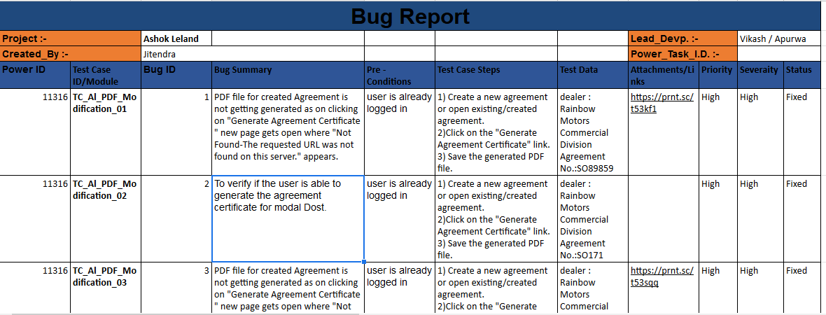

Bug Reporting

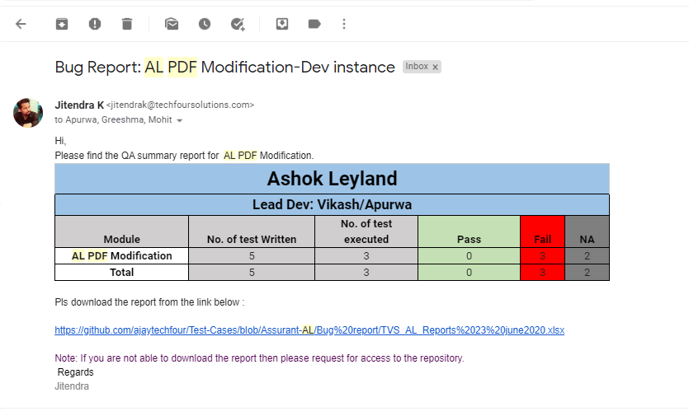

5. Re-Testing & Regression Testing: Within an iteration, we execute integration and system testing several times until the whole system (as defined by the goal of the iteration) functions as intended and meets the test's success and exit criteria.